200705400 - Entiat River - UPA - Stillwater Restoration Project

ISRP Comments/Questions:
If stronger evidence had been presented that bank erosion was having a detrimental impact on the channel at and below the project site, the proposal would have been more persuasive. Establishing the potential significance of the project would also require a more complete description of the sediment problems in the watershed. The significance of erosion at the project site cannot easily be judged without this context. The basic premise of this project is that the production of sediment from the eroding banks is impacting habitat quality and biological productivity at the project site. The only evidence provided is the level of fine sediment in the gravel.
Response: General Overview of Sediment Dynamics and Contribution of Project Site
The USFS completed an ecological land unit inventory of the Wenatchee, Okanogan and Colville National Forests in 1999. Land Type Associations information and data pertaining to percent fine sediment in substrate gravels were used to stratify the Entiat subbasin into three broad, landscape-level sediment analysis zones: Transport, Transitional and Depositional. The figure on the next page depicts the extent of these zones within the subbasin, as well as USFS Entiat RD fine sediment sampling sites.

2005 marked the thirteenth consecutive year of evaluation of fine sediment conditions in three reaches of the Entiat River (RM 0.5-34) by the USFS using the McNeil core sampling method. The Wenatchee National Forest Land and Resource Management Plan (WNF LRMP 1990) states the desired future condition for stream sediment as: "Maintain <20% fines (<1.0 mm) as the area weighted average in spawning habitat (pool tail-outs and glides)."

Sampling reaches 1, 2, and 3 were chosen to coincide with the reach delineation of the 1991 WNF Stream Survey of the Entiat River. Sampling sites were selected based on their suitability for, or known occurrence of, spawning by Chinook salmon, steelhead or bull trout. Sampling sites in Reaches 1 and 2, which overlap the WDFW/USFWS Chinook spawning index reach on the Entiat River, were selected in consultation with WDFW fishery biologists L. LaVoy and B. Steele.

Entiat Reach 1 (RM 18-RM 25) encompasses the Stillwater reach, a low gradient, low velocity depositional area for the system, with a relatively wide (>600 feet) floodplain. Given these features, Reach 1 is expected to have naturally elevated deposition and storage of fine sediment compared to other higher gradient reaches (i.e., Reaches 2 and 3).

Sampling Reach 1 - Site 2, Entiat @ Dill Creek - RM 21.5, is located immediately upstream of the Stillwater project area (project area is RM 21.4). McNeil core sample data from 2005 showed Reach 1 (15.72 percent fines) experienced a slight increase in mean percent fines from 2004 (13.96 percent fines); however, all sampled reaches showed increases from 2004 to 2005. The 2005 mean was less than the 13-year grand mean of 18.34 percent fines. The 13-year trend for Reach 1 is unclear but can be interpreted as a long-term decrease (Archibald and Johnson, 2005). This is encouraging because this reach contains most of the Chinook salmon spawning habitat of the entire subbasin; however, localized areas of accelerated bank erosion are hypothesized to contribute substantial levels fines to the reach.

In order to more clearly classify reach-level processes and sediment contributions to spawning gravels at the proposed project site, additional data were collected. Wolman pebble counts were conducted at three transects in the project reach on March 10, 2006 (See data on the next pages). Mean percent fines <2mm in diameter at the three transects, working downstream to upstream, were found to be 25%, 15% and 38%, respectively. The downstream-most transect is believed to be most representative of project reach conditions (pers. comm., P. Archibald, USFS). See pages 3, 4 and 5 for cross-sectional view and data.
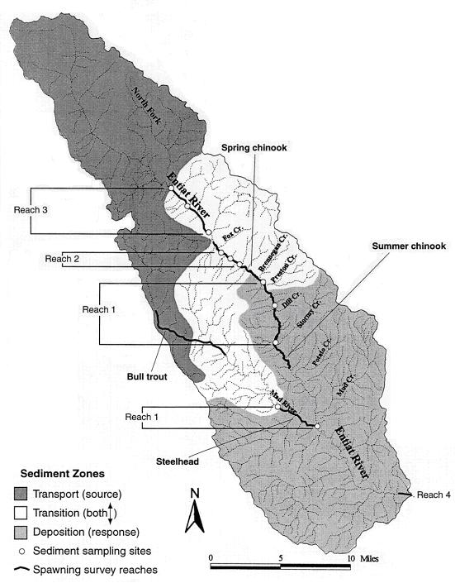

Transect data from the downstream end of the proposed restoration area (transect p1). Fines <2mm in diameter comprised 25% of the total sample, indicating elevated fine sediment levels associated with the project area. This transect believed to be most representative of conditions within the project reach (Pers. comm., P. Archibald, USFS Entiat RD fisheries biologist).

Transect located at apex of point bar mid-project reach. Transect was deliberately located directly on late-run Chinook redd. Redd excavation activity may explain reduced % fines <2mm here.

Transect site located upstream of proposed treatment reach in a long, straight glide / pool tail-out (a natural depositional environment). Therefore, higher levels of fines <2mm here not deemed atypical.

ISRP Comments/Questions:
Bank erosion is attributed to past land-use practices and a lack of riparian vegetation, but it was not clear whether or not this area would erode regardless of past problems. The following questions were not addressed in the proposal, and the ISRP would like a response to them in addition to other concerns listed in the comments.
- Is erosion at this site an important source of gravel for downstream spawning areas?
- Are sediment sources upstream producing sufficient material to supply gravel and maintain channel form?

Response:
The area would erode under properly functioning conditions; however, the rate would likely be inches per year vs. the accelerated rate of 1-2 feet per year that the site is currently experiencing. The proposed project site is located at RM 21.4 in the "stillwater" reach, a low gradient, low velocity depositional area for the system, with a relatively wide (>600 feet) floodplain. The project reach is a Rosgen C4 type, as indicated in part by the d50 of Wolman transects p1 and p2 (see previous graphs). Surficial geology and LTA data indicate the project area is composed of fine, erodible quaternary alluvial material resulting from past glaciation. The alluvial soils at the Stillwater site are not the main source for spawning gravels in the reach -- refer back to photo depicting cross-section of bank at project site that was provided in original application.

The longitudinal profile of the mainstem Entiat, below, depicts the gradient change that begins at the Potato terminal moraine (RM 16.2) and extends to approximately RM 25, the McCrea Creek confluence. Spawning gravels are mobilized from higher gradient areas further up in the watershed (transport and transition zones in previous sediment zones map) and then deposited in the Stillwater area. Recruitment from upstream sources is believed to be working properly and producing sufficient material to maintain gravel supply and channel form.
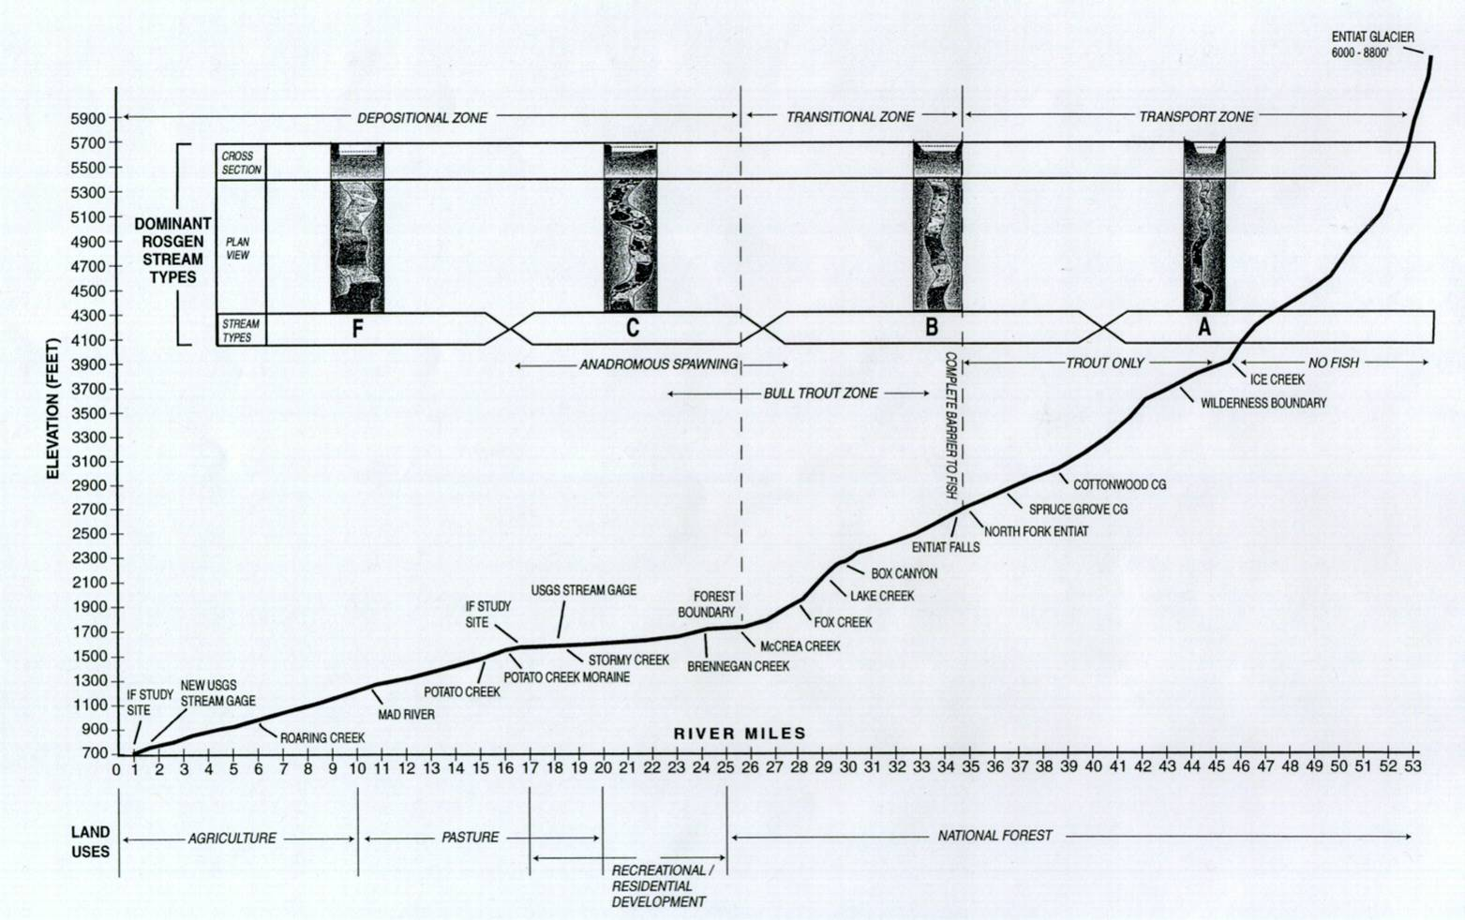
ISRP Comments/Questions:
A large portion of the budget will go toward placing approximately 125 rootwads and 240 cut logs in large woody debris (LWD) complexes to be spaced 10 feet apart. The reason for the 10-feet spacing is that it is believed to be necessary to prevent additional streambank erosion.
Response: The 10 ft spacing is proposed based on results from a past project in the Stillwater area, in a reach with similar geomorphology. Placement of log clusters in the earlier project was not tight enough to prevent scour pockets from forming between the LWD complexes and further accelerating bank erosion. Therefore, the spacing of LWD complexes in the proposed Stillwater project was designed to consider past lessons learned.
ISRP Comments/Questions:
There was no attempt to relate the proposed LWD additions to conditions in a similar, but relatively undamaged part of the Entiat or otherwise similar alluvial river valley. This regular spacing is not likely to occur naturally….
Response: Due to the history and extent of wildfire disturbance within the Entiat subbasin, there is not a reference reach by which to establish natural amounts of LWD transport and loading. The closest comparison that can be made is to a C4 section of the Chiwawa subwatershed within the Wenatchee subbasin; however, we acknowledge that wood loading rates in the Chiwawa are higher than what would be found in the Entiat due to the fact that the Chiwawa receives more rainfall and has a larger riparian area from which to recruit wood.
ISRP Comments/Questions:
…and unless the LWD structures are very securely anchored, movement of the structures during high flow events is almost sure to happen. The objectives did not make clear whether either the structures or riparian plantings would be repaired after natural disturbances.
High flows are likely to alter the distribution of LWD structures and may affect the survival of some replanted riparian areas. Reducing sedimentation from the exposed streambank is a valid objective, but the solution could become costly to maintain if natural disturbance-mediated changes are not tolerated.
Response: The intent of the project is to reslope and revegetate the stream bank, and use LWD complexes as an interim bank protection and habitat complexity restoration measure. We agree that the initial placement of LWD will require secure anchoring. The wood used to initially protect the bank will naturally recruit other LWD that is mobilized during high flows. As the riparian vegetation along the resloped bank becomes established, it will create additional long-term stability and habitat enhancements. The goal of the project is to accommodate wood movement that may occur due to natural disturbances. If LWD that is installed is mobilized and transported as the result of an event, project repair would be undertaken if a portion of the resloped, newly revegetated bank was left exposed / vulnerable and worsened scour and bank erosion. Some riparian plant mortality will likely occur; funds have been budgeted for replanting. Once native species such as willow and others with extensive root complexes have become established, the goal is for areas disturbed by natural events to be recolonized by natural processes via the new riparian species.
ISRP Comments/Questions:
Also, there is some confusion regarding the level of wood being added to the project reach. The background information provided at the beginning of the proposal indicates a desired level of large wood of about 20 pieces per mile of channel. However, this project plans to add a total of 365 pieces to about a half-mile of channel. We recognize increasing wood abundance is secondary in this project to bank armoring, but some indication of possible consequences of increasing wood levels to more that 15X the stated objective should be explored in the proposal.
Response: The “20 pieces per mile” is a minimum target for the whole reach but is not a prescription for proposed restoration of the site. At this particular site, the goal is to mimic the natural process that occurs in Rosgen C4 reference reaches – i.e. accumulation of wood in large jams -- and to use install pieces of LWD in wood complexes in the Stillwater project. The picture below shows a wood jam that has formed within the project reach by wood hanging up on historic tree stumps in the channel.
We estimate that this may take 365 pieces but until a preliminary design has been developed, it is impossible to quantify exactly how much wood will be utilized or how it will be placed. However, District staff and partner agency fisheries biologists and engineers developed an estimate of how many total pieces of wood and of what size would likely be needed for the length of bank in the project reach in order to develop a sound materials construction budget. A complete topographic survey of the site has been conducted, and the goal is to complete preliminary design on the project later this year for construction next fall. This large number of pieces will insure a proper spacing between pieces that prevents bank erosion seen at previous projects where wood was spaced too far apart.
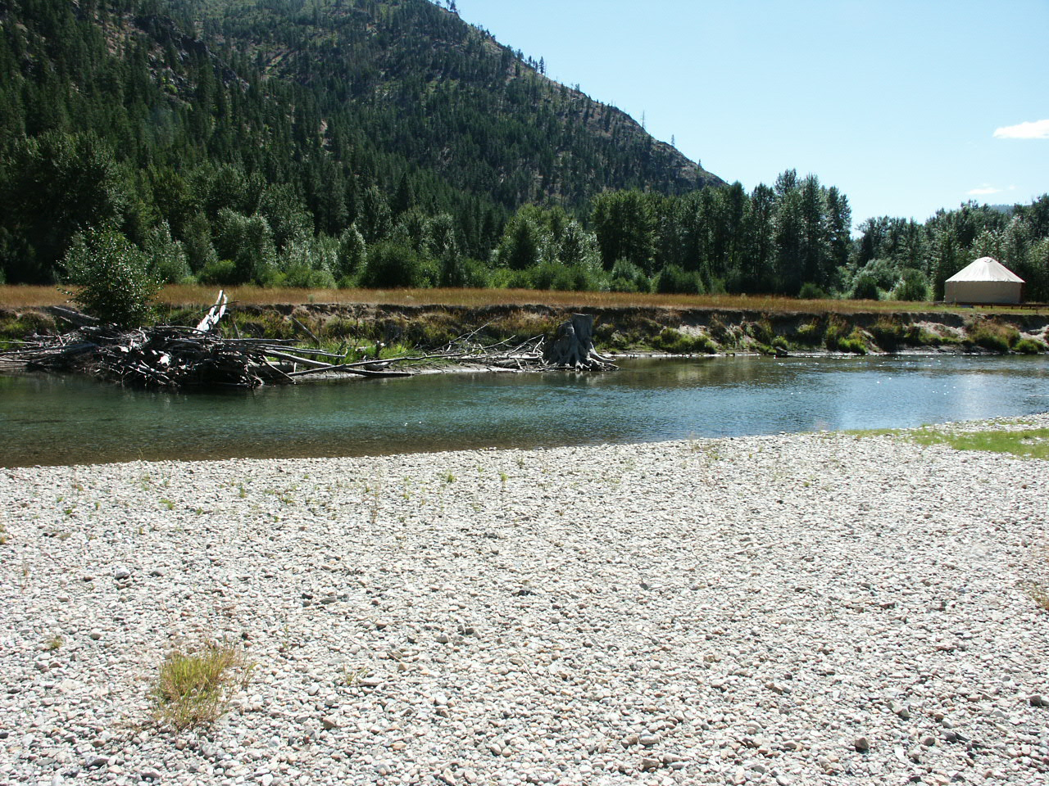
ISRP Comments/Questions:
The objectives tend to be generic, and in some cases the linkage between the project elements and the desired outcome is not clear. For example, the proposal indicates one of the biological outcomes is an increase in nutrient delivery to the channel as a result of riparian tree plantings. Although an increase in organic matter delivery to the stream with the re-growth of riparian trees and shrubs is likely, nutrient input may actually decline as a result of uptake by the new vegetation.
Response: Past water quality monitoring performed by the USFS Entiat RD does not indicate that significant contributions of nitrogen or phosphorous to this part of the river are occurring as a result of overland runoff. Therefore, the vegetation that is reestablished in the project area will not substantially alter this form of nutrient input to the river. The project strives to enhance the amount of allochthanous nutrient inputs from the riparian zone, as food supply available for fish is affected by this parameter, the quantity of salmon carcasses, and the health of the benthic invertebrate population in addition to stream alkalinity (Mobrand Biometrics, Inc. 2003).

ISRP Comments/Questions:
Not enough detail is provided on the monitoring component of the project to evaluate it. However, the information that is provided raises some concerns. Many of the variables that are proposed are highly variable, both spatially and temporally (e.g., gravel fines, macroinvertebrates, and fish). The proposal implies that pre-treatment information on these parameters will be collected one time. There is very little possibility that a measurable response could be detected based on a single pre-treatment sample. Additional details should be provided to justify the work

Response: The proposed monitoring is an example of “implementation monitoring” (Hillman 2005) that will be accomplished within the modest monitoring funds requested by the proposal (BPA’s guidance is a 5% soft cap on monitoring activities). Hillman (2005) distinguishes between “implementation monitoring” which is the level that should be done by each project to show that the action was implemented properly and has at least affected the environmental parameters that were the target of restoration as compared to “effectiveness monitoring” that includes more detailed information on changes in environmental and biological parameters.

An more intensive “effectiveness monitoring” program is underway by NOAA and BPA (Project #2003-017, the Integrated Status and Effectiveness Monitoring Program [ISEMP]) in the Entiat subbasin to demonstrate effectiveness at the reach and subbasin scales. The ISEMP program monitors at the project/reach scale through pre- and post-treatment habitat and snorkel surveys at three seasons per year (summer, fall, and winter) at 18 control and 18 treatment locations in a Before-After Control-Impact (BACI) design. The site this proposal will treat is included in the ISEMP program. Furthermore, ISEMP is implementing monitoring of subbasin-scale indicators (e.g. smolts-per-redd) that will be affected, in small part, by this proposed project.

Hillman, T. 2005. Project Monitoring: A guide for sponsors in the Upper Columbia Basin. Prepared for the Upper Columbia Salmon Recovery Funding Board and Mid-Columbia HCP Tributary Committees. November 1, 2005 draft report.

